**Name: k reddy purandhar**

**Reg.no: 192011484**

Experiment no:3

Design and Configuration of Bus Topologies using Packet Tracer

### AIM:

Configuration of Bus Topologies using Packet Tracer.

### REQUIREMENTS:

1) **End device** - They are the devices through which we can pass

message from one device to another and they are

2) **Switch/Hub** - Interface Between two devices.

3) **Cable** - Used to connect two devices.

Procedure:

**1)** Click on end devices, select generic Pc’s drag and drop it on the

window. Click on SWITCH drag and drop it on the window.

**2)** Select the straight through cable and connect all end device to switch. Assign the IP address for all end devices. (Double click the end device Select →

desktop → IP configuration static)

**3)** Now set the IP address to Host A (192.168.1.1) in static mode. Similarly set IP address for Host B (192.168.1.2) and Host C (192.168.1.3)

**4)**To view the IP address, give ipconfig command in command prompt. Using ping command, we can establish communication between two host devices.

**5)**Now display the packet transmission in simulation mode.

Bus Topology:

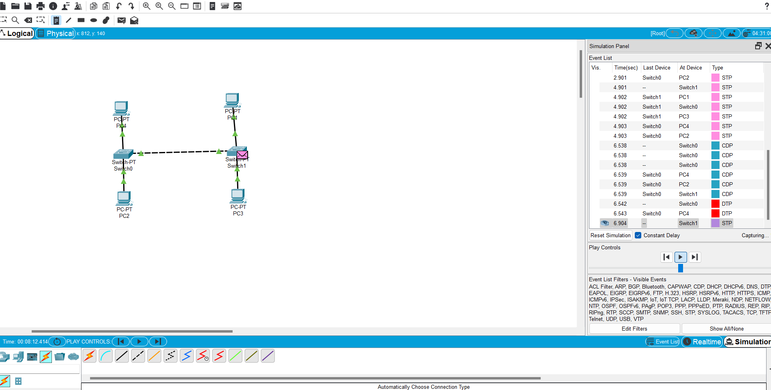

RESULT:

Configuration of Bus Topologies using Packet Tracer communication is verified successful.